arcmap 发布数据

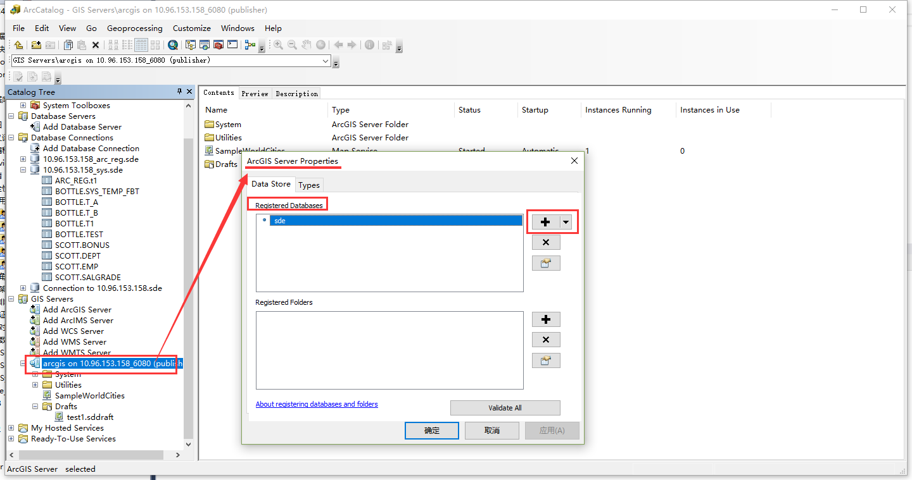

**00090: <value> requires a registered database**

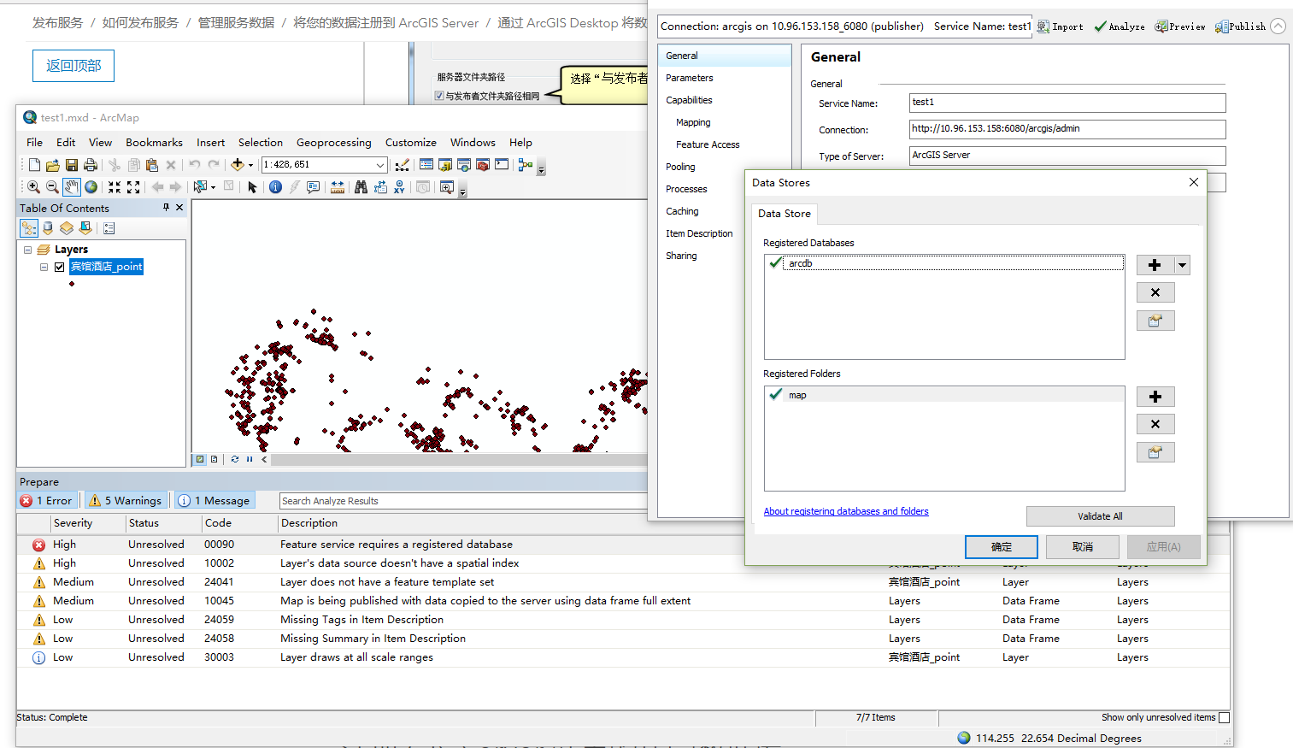

SEVERITY STATUS CODE DESCRIPTION NAME TYPE DATA FRAME

High Unresolved 00090 Feature service requires a registered database Layers Data Frame Layers

编辑的要素需要先添导入到数据库.然后再打开编辑后,发布,就可正常了.